
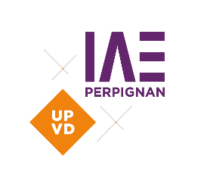
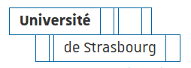




Chaire Vin et Tourisme

WORKSHOP REGISTRATION FORM

4th International Research Workshop on
Wine Tourism and Agrifood: Resilience and Transitions

15-17th October 2025 Perpignan, France

PERSONAL INFORMATION

Full Name:
Email Address:
Phone Number:
Mailing Address (if needed):
ACADEMIC / PROFESSIONAL AFFILIATION

Institution / Organization:
Position / Title:
Field of Expertise / Discipline:
SCIENTIFIC PARTICIPATION

Are you submitting a paper or an abstract? Yes No

If yes, please provide the following:

- Title of the presentation:

- Keywords (3–5):

- Authors and co-authors:

- Technical requirements for presentation (e.g., projector, sound, etc.):

LOGISTICS AND SPECIAL REQUIEREMENTS

Will you participate in the organized meals (welcome drink, lunches, dinner)?
Yes No Partially (please specify: )

Dietary requirements:
Vegetarian Vegan Gluten-free Allergies (please specify: )
None

Accessibility or special needs:
Yes (please specify: ) No

REGISTRATION FEES

Registration category:
PhD Student: 180 €
Academic / Researcher: 250 €
Professional: 250 €
Spouse / Accompanying person: 140 €
Payment method:
The payment must be made by bank transfer.
Payment reference: “WTAF octobre 2025 IAE-MRM”

Do you need a proof of payment? Yes No

To complete your registration, please send the completed form to the following address: jodie.esteve@univ-perp.fr

For further information please contact: wtaf2025workshop@univ-perp.fr
With the support of

